1) git –version  
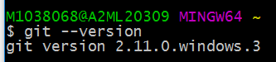

2) 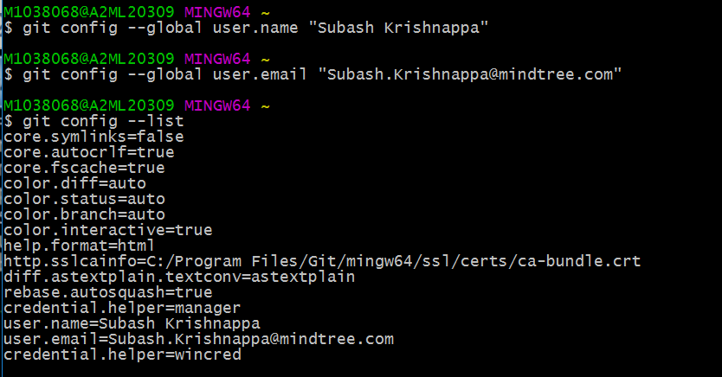

3) Clear screen

Command is “clear “

4) To view only one config, we must provide a config name as below  
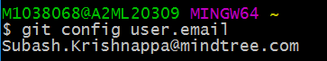

5) git help command:  
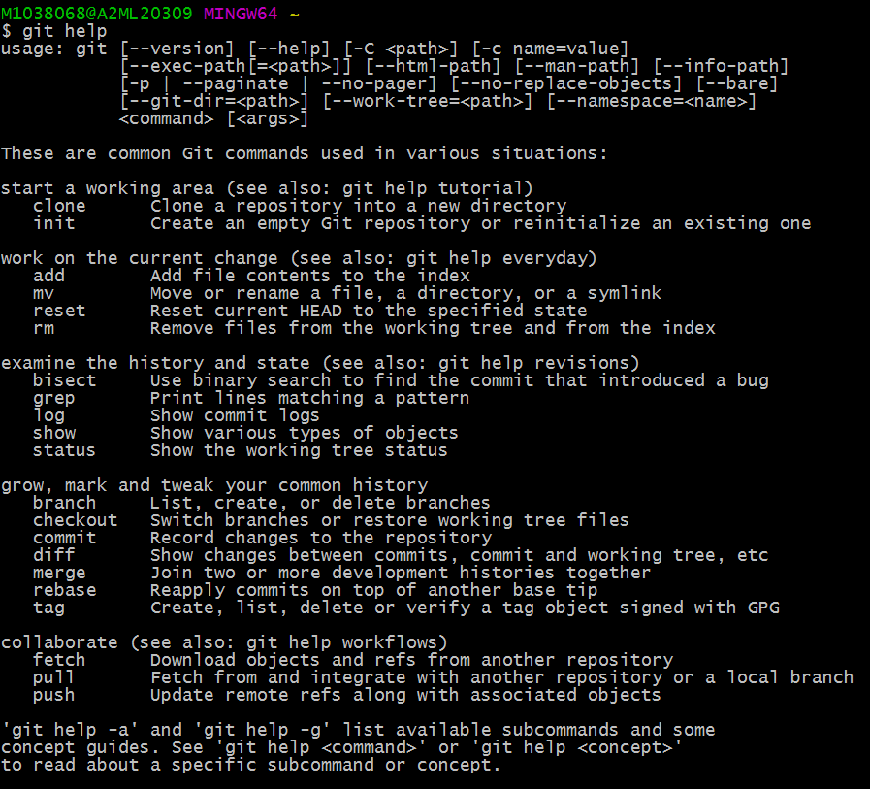

6) Initialise a git project:  
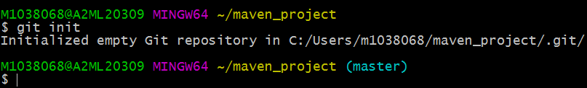

7)ls –la will display all files, including hidden folders

8) 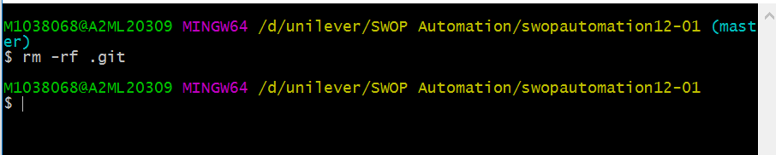

9) 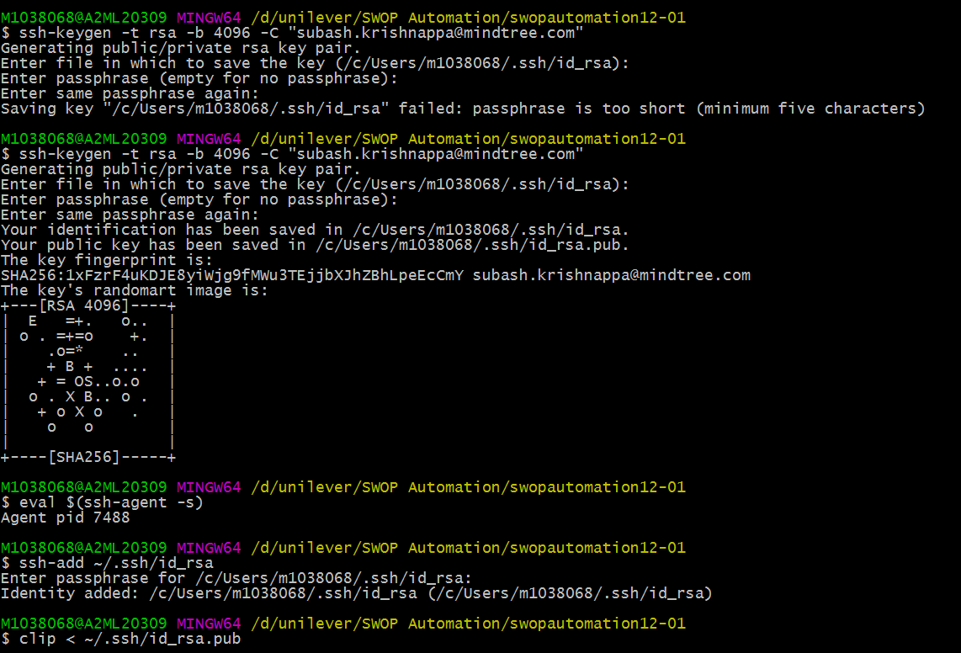

10) click SSH keys  
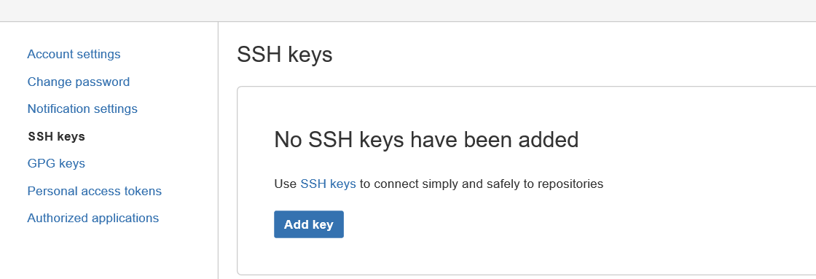

11) 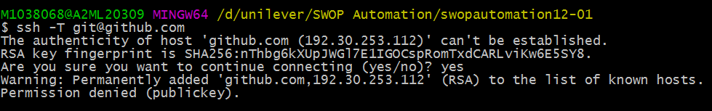

12) 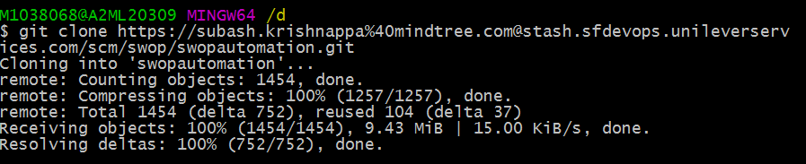

MAVEN Tutorial  
1) Central repository for dependencies  
2) maintain common structure across organization  
3) Fliexibity in intergrating with CI Tools  
4) Used for test execution  
5) Group ID identifies our project uniquely across all projects  
6) artifact ID is the jar name  
7) mvn eclipse:eclipse -> integrate maven with eclipse, .classpath and .project will be get created with this command  
8)Maven surefire plugin is necessary to excute tests using maven in test folder  
9)